One-Sample T: Weight
Descriptive Statistics
N | Mean | StDev | SE Mean | 95% CI for μ
50 | 49.620 | 6.577 | 0.930 | (47.751, 51.489)
μ: mean of Weight
Test
Null hypothesis | H₀: μ = 50
Alternative hypothesis | H₁: μ ≠ 50

T-Value | P-Value
-0.41 | 0.685

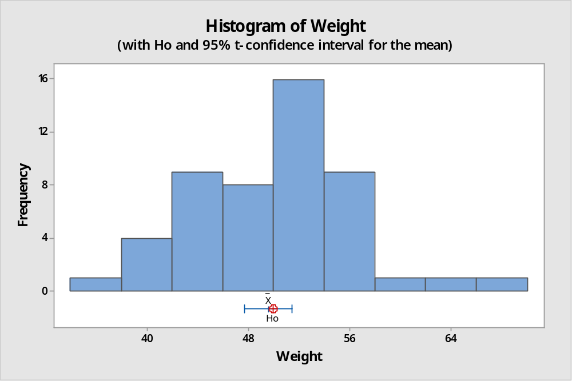

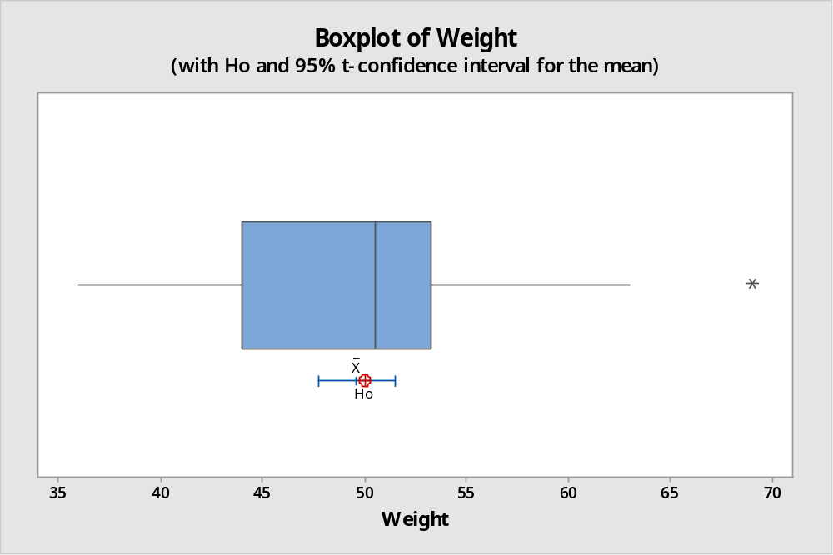

Conclusion:
The graph of box and whisker plot and histogram shows that the data is left skewed i.e. not normally distributed. Hence, t-test for mean is not valid test for population mean because it violates the fundamental assumptions that the data is normally distributed. The alternative test could be Wilcoxon signed rank test or sign test.
Further p-value=0.685>α-value=0.05, we accept the null hypothesis that the mean weight of metal ring is 50 ounces. The 95% confidence interval for population mean (µ) is 47.75 ounce to 51.49 ounce.

